**Big data activity 1**

**25156**

**Note:**

I mistakenly ran the file manipulation commands in ubuntu instead of alpine, however the results would be roughly similar and I don’t want to waste the progress I did so please check this with that in mind.

**File manipulation:**

**Copying multiple files to directory**

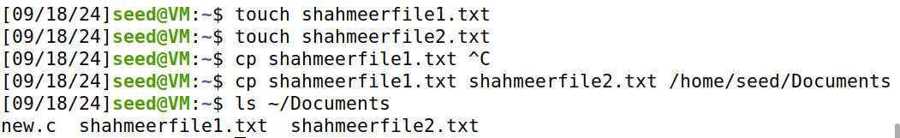

**Copying an entire directory to a new directory**

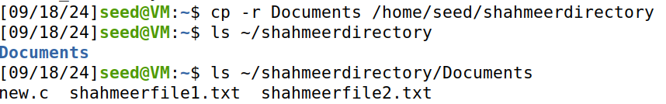

**Changing permissions and viewing outputs**

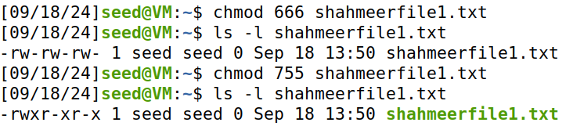

**Changing owner of file**

I first used ls -l to get the owner as seed

To then change it to user i created a new user “user1” and then changed ownership

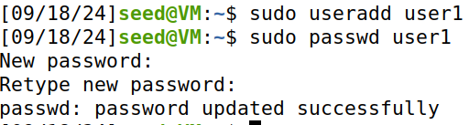

Here we can see the changed ownership

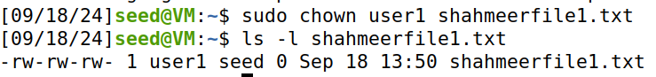

**Changing group for a file**

Creating a group



Changing group ownership



**Disk usage**

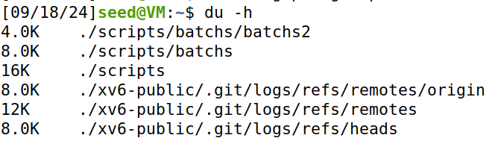

Displayed a lot of data so summarized to the end  
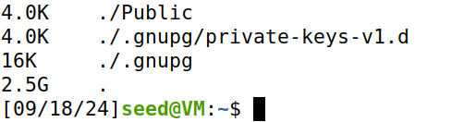

**Free disk space**

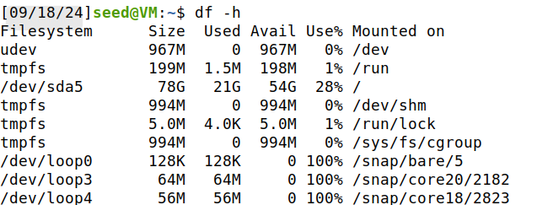

**Sync command**

This command is used to synchronize file system buffers with the disk, it does this by forcing the system to write buffered data to the disk.



**Process management**

**Increasing and showing running processes**

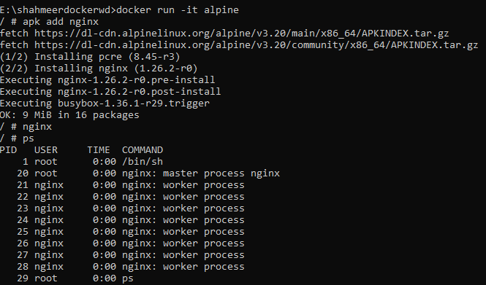

**To also show system processes**

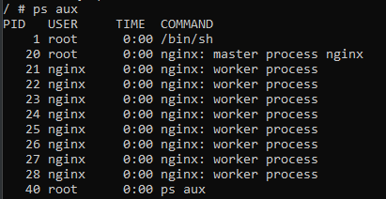

**Kill process**

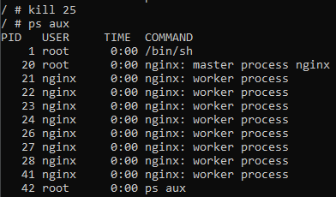

**Kill root process**

The reason for the multiple root processes is that many services like nginx start at root then switch to a less privileged user, here I killed the root process for nginx (PID 20)

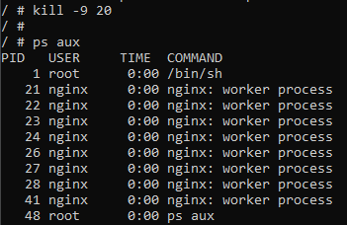

**Changing priorities**

Priorities determine the amount of CPU time a process receives relative to other processes and are judged based on nice values, ranging from -19 (highest priority) to 20 (lowest priority).



I faced errors with this so I tried using sudo which didn’t work, I also confirmed that I’m root using whoami so I don’t understand how to fix this.

**Effect of priority changing**

Since I couldn’t set a priority in the previous instruction, I can’t show its effect either.

**Finding process id using name**



**Top command**

This shows a real time review of CPU usage

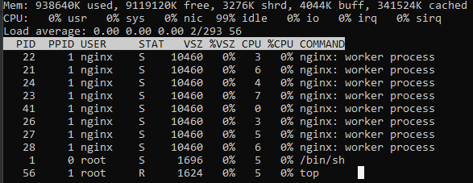

**Iostat command**

This helps us analyze how much data is being read from and written to the disk

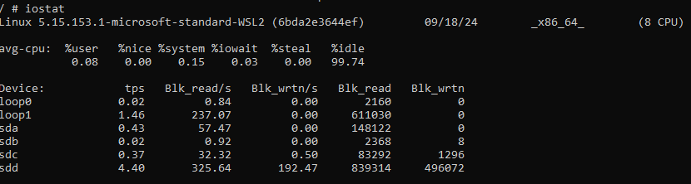

**Run in background**

This allows us to execute a command/program without blocking the terminal so its used for other tasks.

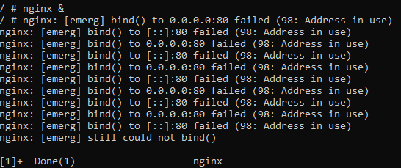

**System info and monitoring**

**Check date and change**



**Check hostname**

This is a label assigned to a machine in a network to identify it.



**System architecture**

Microsoft Standard WSL2 refers to the version 2 of the Windows Subsystem for Linux (WSL), which is an enhanced version of the original WSL

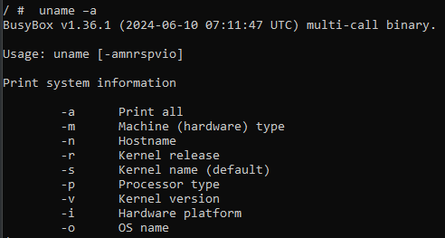



**Ipaddr command**

lo Interface: Loopback interface used for internal communication on the same machine. It has the IP address 127.0.0.1 for IPv4 and ::1 for IPv6.

eth0 Interface: Physical network interface typically used for external network connections. It shows the assigned IP address (192.168.1.10), broadcast address, and IPv6 address.

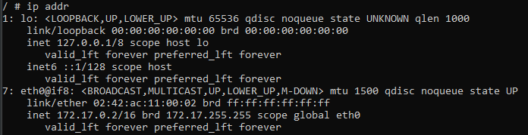

**Printenv command**

Lists environment variables in VARIABLE=value format, showing settings that affect the shell and processes.

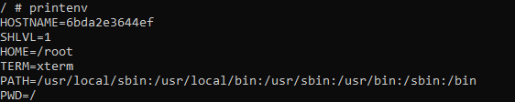

**Free -h command**

RAM (Mem:)

* total: Total physical RAM.
* used: RAM currently in use.
* free: Unused RAM.
* shared: RAM used by multiple processes.
* buff/cache: RAM used for buffers and cache.
* available: RAM available for new processes.

Swap (Swap:)

* total: Total swap space.
* used: Swap space currently in use.
* free: Unused swap space.

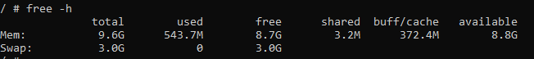

**Dmesg command**

WSL_ROOT_INIT=1: Indicates that the WSL (Windows Subsystem for Linux) root initialization is enabled.

debug: Enables kernel debugging messages.

Intel GenuineIntel: The kernel supports Intel CPUs.

AMD AuthenticAMD: The kernel supports AMD CPUs.

Centaur CentaurHauls: The kernel supports Centaur CPUs.

[mem 0x0000000000000000-0x000000000009ffff] usable: Indicates a range of physical memory available for use.

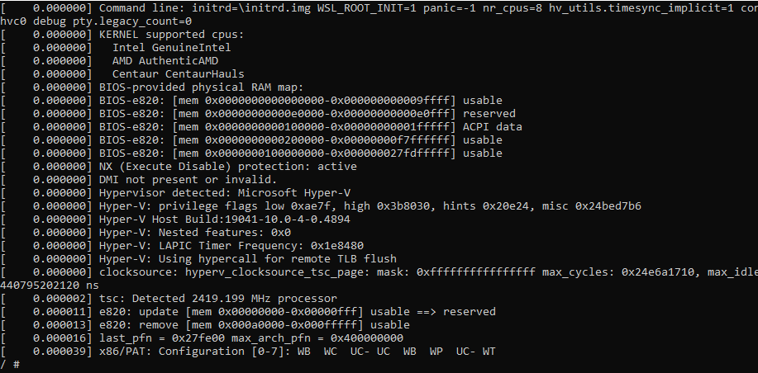

**Networking commands**

**Connectivity to ipv6 host**

IPv6 (Internet Protocol version 6) is the most recent version of the Internet Protocol (IP), designed to replace the older IPv4.

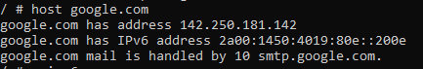



Unfortunately, it couldn’t ping to google

**Ip -a command**

lo and eth0 are the loopback and network interfaces respectively, brd refers to broadcast, the inet for both is for ipv4 addresses, the /16 is the subnet mask

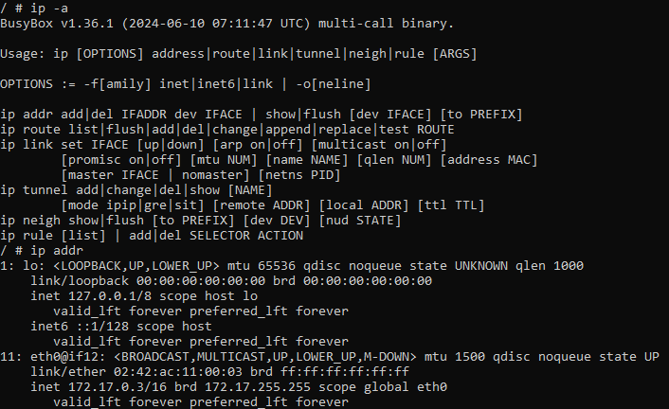

**Ip link show**

This command provides details about the network interfaces, including their status, MAC addresses, and other attributes.

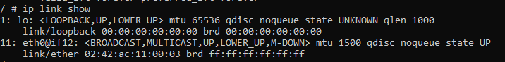

**Ip addr add command**

Permission denied possibly due to lack of privileges, tried using sudo to bypass but didn’t work.



**Eth0 up down commands**

Permission denied when trying eth0 down

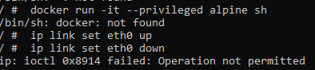

**Configure network interface**

eth0: Represents the primary network interface with IP address 172.17.0.3 and is part of a network with a 255.255.0.0 subnet mask.

lo: The loopback interface used for internal communication within the system, with IP address 127.0.0.1 and an IPv6 address of ::1.

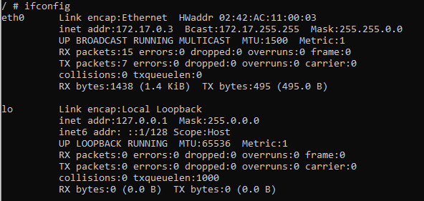

**Ip routing table**

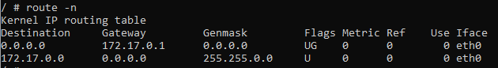

Explanation for route 2

**Destination: 172.17.0.0** : This is a specific subnet route.

**Gateway: 0.0.0.0** : No gateway needed; the destination is directly reachable.

**Genmask: 255.255.0.0** : Subnet mask indicating the 172.17.0.0 network.

**Flags: U** : The route is up and active.

**Metric: 0** : Default cost.

**Ref: 0** : No references.

**Use: 0** : No usage recorded.

**Iface: eth0** : The route uses the eth0 network interface.

**Traceroute command**

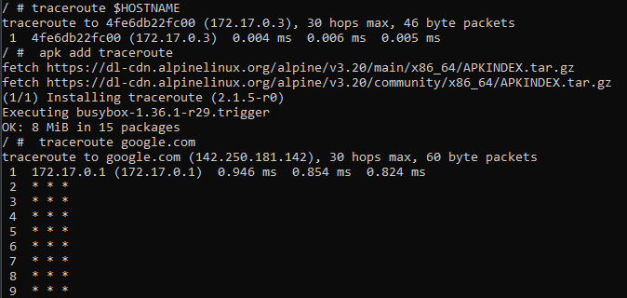

**NS lookup command**

Privileges aren’t required here as DNS lookups are safe for public use

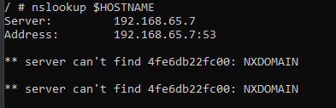

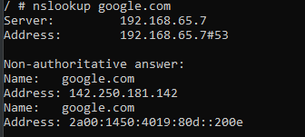

**Dig and host commands**

DNS, or Domain Name System translates human-readable domain names into IP addresses, which computers use to identify each other on the network.

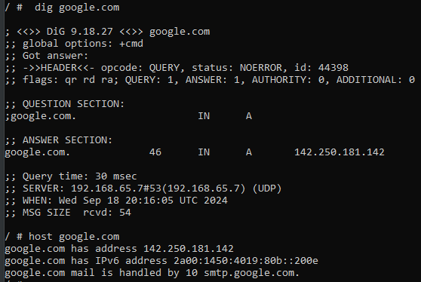

**Netstat command**

The netstat command is used to display network connections, routing tables, interface statistics, masquerade connections, and multicast memberships. The -tuln options are commonly used together to provide specific details about network connections.

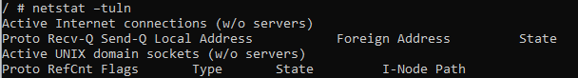

**Curl command**

Even with less it was impossible to read and scroll through due to the excessive detail. Running the command curl connects to the specified URL and retrieves the content of the web page. The output will typically be the raw HTML of the page, showing the structure and content of the website.

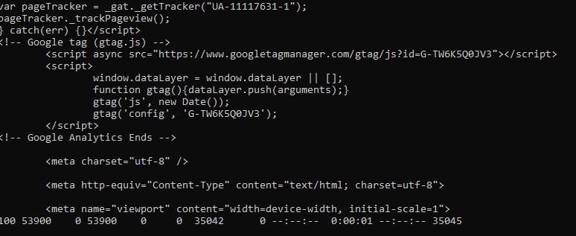

**Iftop command**

Showed a massive screen with not many statistics so had to use ctrl+c to back out

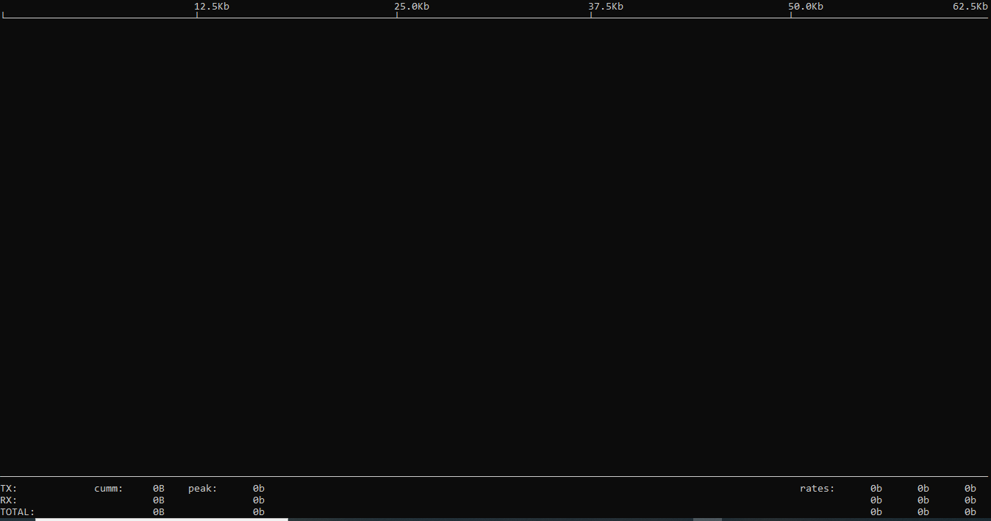

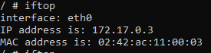

**Telnet command**

telnet google.com 80: Tests TCP connectivity to port 80 on google.com.

Successful Connection: Indicates that the port is open and accepting connections.

